***Anaisy Garcia***

***Spring 2018***

[](https://www.google.com/url?sa=i&rct=j&q=&esrc=s&source=images&cd=&cad=rja&uact=8&ved=0CAcQjRxqFQoTCLz4t43Xq8gCFUXSHgodHjkHtQ&url=https://www.facebook.com/Competitive-Exams-Questions-Of-Computer-373127006115385/timeline/&psig=AFQjCNGTDdSN_DiPKgDEkLvqVXcJ2qd7jQ&ust=1444146484377830)

***Problem 1(10 Points):*** *Write a “C” program to draw a rectangle with “*” that includes you initials. The initials should be written as follows.*

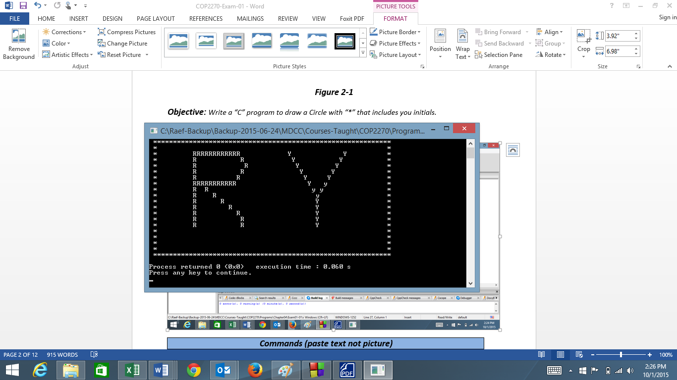

*Hint Use simple printf command with many lines and adjust as you go*

|  |
| --- |
| ***Commands (paste text not picture)*** |
| ***#include <stdio.h>***  ***int main()***  ***{***  ***printf("********************************************************\n");***  ***printf("* A GGGGGGGGGGGGGGGGGG *\n");***  ***printf("* A A G G *\n");***  ***printf("* A A G G *\n");***  ***printf("* A A G *\n");***  ***printf("* A A G *\n");***  ***printf("* A A G *\n");***  ***printf("* A A G GGGGGGGGGGG *\n");***  ***printf("* AAAAAAAAAAAAAAA G G G *\n");***  ***printf("* A A G G G *\n");***  ***printf("* A A G G *\n");***  ***printf("* A A G G *\n");***  ***printf("* A A GGGGGGGGGGGGGGGGG *\n");***  ***printf("********************************************************\n");***  ***}*** |

|  |
| --- |
| ***Output (paste picture)*** |
|  |

***Problem 2 (15 points):*** *Write a “C” program to calculate the area of the following geometric shape.*

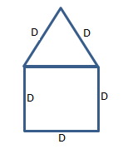

|  |
| --- |
| ***Commands*** |
| ***#include <stdio.h>***  ***#include <stdlib.h>***  ***#include <math.h>***  ***int main(void)***  ***{***  ***float D1;***  ***float D2;***  ***float D3;***  ***float height;***  ***float areaTriangle;***  ***float areaSquare;***  ***float areatotal;***  ***printf("Enter the value of top side one:\n");***  ***scanf("%f", &D1);***  ***printf("Enter the value of base:\n");***  ***scanf("%f", &D2);***  ***printf("Enter the value of left side:\n");***  ***scanf("%f", &D3);***  ***height = pow(D1,2)+pow(D2,2);***  ***areaTriangle = ((D1+height)/2);***  ***areaSquare = (D2*D3);***  ***areatotal = (areaTriangle + areaSquare);***  ***printf("The area of this geometric shape is = %.2f\n", areatotal);***  ***}*** |

|  |
| --- |
| ***Output*** |
|  |

***Problem 3 (20 points):*** *Modify Problem 4.23 from your text such as*

* *Once you run the program it will prompt you for* 
  + *Please input the principle amount in dollars and cent such as 10000 means $100.00*
  + *Please enter the interest rate in percent such 5 means .05*
  + *Enter the number or years.*

*Once you enter the last value, it would give similar list to the result in the book*

|  |
| --- |
| ***Commands*** |
| ***#include <stdio.h>***  ***#include <math.h>***  ***int main(void)***  ***{***  ***unsigned int years;***  ***float a= 0.0;***  ***int x;***  ***int year;***  ***float rate = 0.0;***  ***float principal = 0.0;***  ***float amount = 0.0;***  ***float totalyears=0.0;***  ***float totalamount=0.0;***  ***printf("Please input the principle amount in dollars and cents (so 10000 is equal to $100.00):\n", principal);***  ***scanf("%f", &principal);***  ***printf("Please enter the interest rate in percent (so 5 is equal to .05):\n", a);***  ***scanf("%f", &a);***  ***printf("Enter the number of years(-1 to end):\n", years);***  ***scanf("%u", &years);***  ***while(years != -1){***  ***rate = a/100;***  ***double amount = principal * pow(1.0 + rate,years);***  ***printf("Amount on deposit:%.2f\n", amount);***  ***printf("\nEnter the number of years(-1 to end):\n", years);***  ***scanf("%u", &years);***  ***}***  ***printf("%s%21s\n", "years", "amount on deposit");***  ***for(years=1; years<=x; ++years){***  ***x=10;***  ***rate = a/100;***  ***double amount = principal * pow(1.0 + rate,years);***  ***printf("%4u%21.2f\n",years ,amount);***  ***}***  ***}*** |

|  |
| --- |
| ***Output*** |
|  |

***For problem 4, choose either 4A (25 points) or 4B (only 18 points). Note if you choose B, then the maximum points you can get is a 93***

***Problem 4A: (25 Points)*** *Write a “c” program to (1) list the odd numbers from 1 to 99 in two different columns (2) then add all of the integers together (1 + 3 + 5+7+…..+99)*

|  |
| --- |
| ***Commands*** |
| ***#include <stdio.h>***  ***#include <stdlib.h>***  ***#include <math.h>***  ***int main()***  ***{***  ***int a;***  ***int b;***  ***int sum=0;***  ***int sum1=0;***  ***int sum2=0;***  ***for(a=1; a<=49; a+=2){***  ***b=a+50;***  ***printf("%d\t%d\n",a,b);***  ***}***  ***for(b=1; b<=99; b+=2){***  ***sum+=b;***  ***}***  ***printf("Sum is: %d\n", sum);***  ***}*** |

|  |
| --- |
| ***Outputs*** |
|  |

***Problem 4B: (18 Points)*** *Write a “C” program to (1) list the odd numbers from 1 to 99 in a single columns (2) then add all of the integers together (1 + 3 + 5+7+…..+99)*

|  |
| --- |
| ***Commands*** |
| ***#include <stdio.h>***  ***#include <stdlib.h>***  ***#include <math.h>***  ***int main()***  ***{***  ***int a;***  ***int sum=0;***  ***for(a=1; a<=99; a+=2){***  ***printf("%d\n", a);***  ***sum += a;***  ***}***  ***printf("Sum is: %d\n", sum);***  ***}*** |

|  |
| --- |
| ***Outputs*** |
|  |

***Problem 5 (30 points):*** *As discussed in class duplicate the following figure using calculation in C*

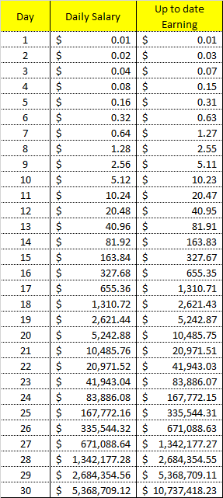

|  |
| --- |
| ***Commands*** |
| ***#include <stdio.h>***  ***#include <math.h>***  ***int main(void)***  ***{***  ***int day;***  ***double dailysalary;***  ***double total;***  ***float earnings;***  ***printf("%4s%20s%30s\n", "Day", "Daily Salary","Up to Date Earnings");***  ***for(day=1; day<=30; ++day){***  ***dailysalary = pow(2,day-1)/100;***  ***earnings += dailysalary;***  ***printf("%4u%20.2f%30.2f\n",day,dailysalary,earnings);***  ***}***  ***}*** |

|  |
| --- |
| ***Outputs*** |
|  |